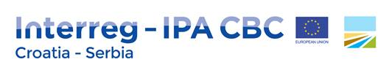
Project title: Mosquito Control in Cross-border Area 2
Project acronym: MOS Cross 2

About project:
Every year, there is greater number of mosquito borne diseases-MBD cases reported in Europe, the most dangerous- malaria, with global effects. The consequences of climate changes are evidenced by frequent floods that provide excellent preconditions for the increase of mosquito population in the region since mosquitos need water for their development. Since 2010 the project area faces a serious problem related to the presence of malaria, chikungunya and dengue fever that in some cases ended with unfortunate deaths of some patients.
During the implementation of MOS-Cross, public awareness was raised and the first data on MBDs were gathered. MOS Cross2 is built on this knowledge and raised institutional capacities gained during MOS Cross1. It will include new viruses and pathogens: malaria, chikungunya and dengue fever. The “Upgraded Joint emergency protocol in case of MBD epidemic outbreak” will be introduced to added project areas. The overall objective is to improve public health services with regards to MBDs by introducing a monitoring system with the aim of ascertaining the presence of invasive mosquito species and control in the cross-border area.
Project duration: 15. 3. 2021. -14. 3. 2023. (24 months)
Total budget: 984 670. 78 €
Amount of EU co-financing: 836 970.14 €
Priority axis: Improving the quality of public social and health services in the programme area.
Lead partner: Teaching Institute of Public Health for the Osijek-Baranja County
Project partners: Public Health Institute Sombor, Institute of Public Health for the Požega-Slavonia County, European Affairs Fund of Autonomous Province of Vojvodina, Institute of Public Health of Vojvodina

This project was co-financed by European Structural and Investment Funds as part of programme Interreg-IPA CBC Croatia- Serbia.

